[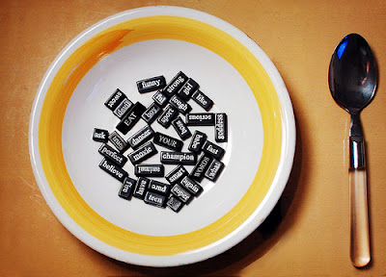](http://2.bp.blogspot.com/-5aP6P6ovu9k/UAZMTiSL7dI/AAAAAAAAGMU/ELLU2CmM7lg/s1600/eating-my-words.jpg)

Me: When will writing happen again?

*Me: Finish eating first! Cannot breathe and swallow at the same time.*

Me: What?

*Me: Trying to eat bread with a fork? Look, all the crumbs are scattering on the paper and table. Dirtying the paper. Write with what? With a fork in the tongue?*

Me: There is no fork in my tongue?

*Me: Finish eating first. Have been eating for quite sometime now. Too much eating leads to constipated thoughts like these.*

Me: Hey get it straight! Why don't we write tonight?

*Me: Look, there's something in your mouth!*

*And these days, there's always something in your mouth.*

[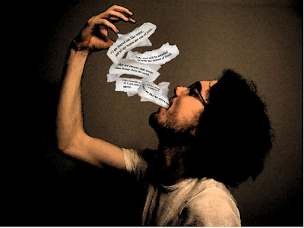](http://2.bp.blogspot.com/-ZInaOtnByiA/UAZMZ4eAvtI/AAAAAAAAGMc/NVNVLzY6e_k/s1600/man-eating-poetry.jpg)

Reading and writing are like breathing and eating. Read too much, and not pause to write, or write too much and not read are for a while pose equal threat to the steadiness of the hand. The first might lead to no thought, while the second leads to superficial ones. Empty the plate often, and wash it dry. The film of staleness shrouds the fine crockery art.